

VLSI testing
Exercises


LAB 1: ATPG and fault simulation (1)

Exercise 1: Deterministic ATPG (path sensitization) for fan-out free circuit
  - Determine the number of all potential fault sites for the circuit shown in Figure 1.
  - Use path sensitization to run ATPG for f/1 and h/1 stuck-at faults for the circuit shown in Figure 1.
  - Given resultant test vectors, determine the expected value on the output (line z).
  - Save test patterns in a format provided by the description file for combinational designs [Appendix 1].
  - Run fault simulation [Procedure 3] using the test patterns obtained earlier and analyze the performance of the test (including fault coverage) [Procedure 4]. Next, analyze the report regarding detected faults and indicate the target fault.
  - Generate test patterns using Tessent FastScan [Procedure 2] and analyze the performance of the test [Procedure 4].

  - Compare the obtained results.
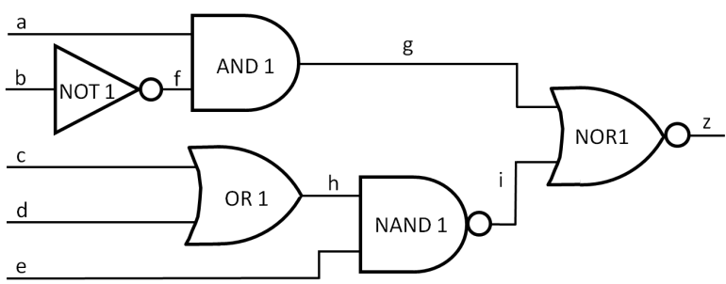
Figure 1: Circuit for exercise 1

Exercise 2: Deductive fault simulation
- Given the circuit shown in Figure 2, use deductive fault simulation for test patterns 01010, 11011, 00110 to determine a list of faults detected on its primary output z.
- Run fault simulation by using Tessent FastScan [Procedure 3].
- Analyze the fault report [Procedure 4] and indicate detected faults.
- Compare the obtained results.
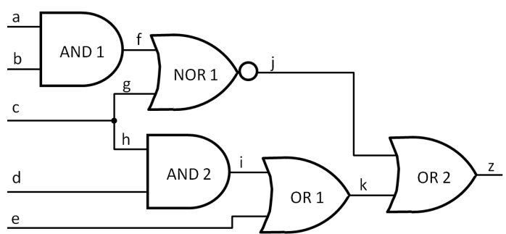
Figure 2: Circuit for Exercise 2

LAB 2: ATPG and fault simulation (2)

Exercise 1: Test set minimization
- Create a fault table for all stuck-at faults in the circuit of Figure 3.
- Determine equivalent fault classes.
- Create a reduced fault table by removing all faults but the first member of each class and undetectable faults.
- Select a minimal set of tests to cover all detectable faults.
- Run fault simulation for the selected set of test set by using Tessent FastScan [Procedure 3].
- Generate test patterns using Tessent FastScan [Procedure 2] and compare the performance (the number of test patterns and test coverage) of both test sets [Procedure 4].
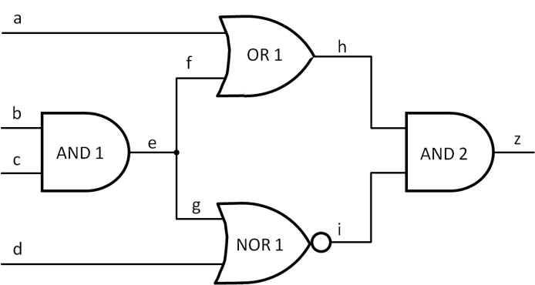
Figure 3: Circuit for exercise 2

LAB 3: ATPG and fault simulation (3)

Exercise 1: Removing redundancy from a circuit with undetectable faults
- Run ATPG for the circuit of Figure 4 using Tessent FastScan [Procedure 2].
- Simulate the circuit using ModelSim [Procedure 5].
- Analyze the performance of the test [Procedure 4] and indicate the list of undetected faults.
- Use the redundant fault class report as guidance and modify the circuit netlist to delete any redundancy in the circuit.
- To assure that your modification did not change the circuit functionality, simulate the modified circuit using ModelSim [Procedure 5] and compare the results.
- Compare complexity (the number of gates and connections) of circuits and test results for the circuit with redundancy and after modifications.

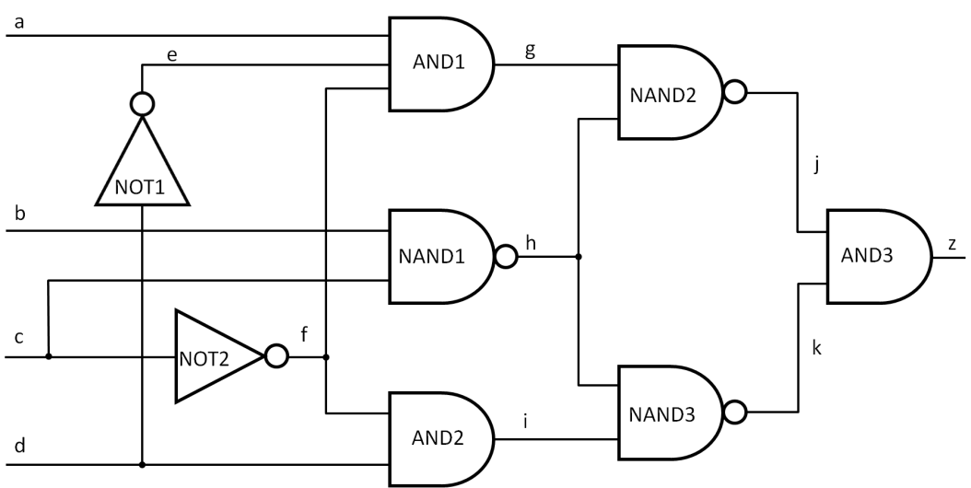
Figure 4. Circuit for exercise 1

Exercise 2: Test point insertion
- For the circuit shown in Figure 4, insert control and observation points to increase test effectiveness without removing redundancy.
- Analyze the performance of the test [Procedure 3] and indicate the list of undetected faults [Procedure 4].
- To assure that your modification did not change the functionality, simulate the modified circuit using ModelSim [Procedure 5] and compare the results.
- Compare complexity (the number of gates and connections) of the circuits and test results for the circuit with redundancy and after modification.

LAB 4: Pseudorandom testing


Exercise 1: LFSR as pseudorandom test pattern generator
- Draw Galois and Fibonacci LFSRs for the following characteristic polynomial: x⁴ + x¹ + 1.
- For these LFSRs generate the maximum length sequence with the initial state (seed) 0001.
- Save the obtained states from Galois LFSR as test sets with the increasing number of test patterns (1.patt – contains state # 1; 2.patt - contains states # 1 and 2, 4.patt – contains states from # 1 to 4, 8.patt - contains states from # 1 to 8, 16.patt contains states from # 1 to 16) for circuit C1 (c1.v) according to the test vector description file [Appendix 1].
- Run fault simulation (c1.run – invocation, c1.do – set of commands) [Procedure 3] for circuit C1 using the prepared test sets and present the resultant fault coverage (c1.log).

Exercise 2: Pseudorandom testing of combinational circuit
- Write a function (for example in C++: /lfsr_cpp/lfsr.cpp), which allows generating a test pattern description file [Appendix 1] by using an LFSR with a given characteristic polynomial, a specific initial state and the length of a generated sequence.
- Apply the above function (/lfsr_cpp/lfsr) to generate pseudorandom test pattern sets (# test patterns according to Table 1) for circuit c6288 (c6288.v). Assume that each LFSR stage is connected with a designated input of CUT. Select the proper primitive polynomial from Appendix 3.
- Run fault simulation (c6288.run – invocation, c6288.do – set of commands) [Procedure 3] for the obtained test sets and circuit c6288 to analyze the performance of the test (fault coverage) [Procedure 3].
- Complete the Table 1 and present the resultant fault coverage as a function of the applied pseudorandom test patterns (see Figure 5).
- Draw conclusions about the effectiveness of pseudorandom testing.
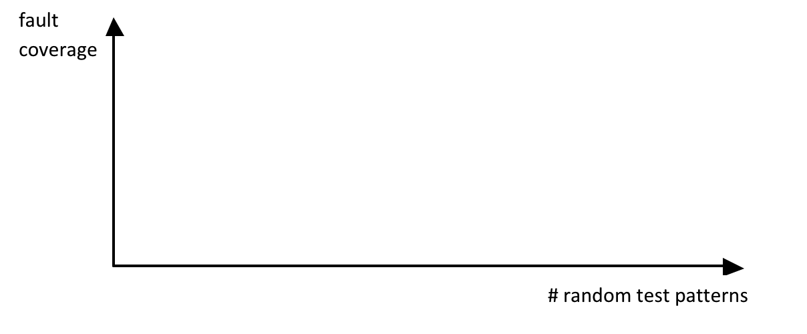
LAB 5: Design for testability (DFT)
Figure 5: The effectiveness of generated patterns
Table 1: Test patterns statistics for exercise 2


Exercise 1: Basic scan insertion
Go to directory lab_5/ex_1. Notice that each step of this exercise has its own subdirectory and common directories are used for netlists, libraries, and reports.
- In 0_lspec_synth synthesize design from RTL HDL description to gate level Verilog netlist using Leonardo Spectrum [Procedure 7].
- In directory 1_scan invoke the Tessent Scan and insert 100 scan chains into synthesized netlist [Procedure 8].
- Report and analyze the statistics.
- Determine the number of simulation gates, the number of sequential elements in this circuit, and the number of scan cells.

Exercise 2: Scan and ATPG flow
Go to directory lab_5/ex_2. Notice that each step of this exercise has its own subdirectory and common directories are used for netlists and libraries.
- In a manner similar to that of exercise 1, insert 4 scan chains into netlist cpu.v.
- In directory 2_atpg invoke Tessent FastScan on the scan-inserted netlist (4 scan chains) and create test patterns (also in a parallel form).
- Analyze ATPG messages and test coverage statistics.


LAB 6: Built-In Self-Test (BIST)

Exercise 1: BIST
Consider a BIST scheme shown in Figure 6 for combinational design C1 (CUT). An LFSR with the characteristic polynomial x³ + x² + 1 and the initial state 111 has been deployed on the input side of C1 as a pseudorandom test pattern generator. Also, a MISR with the characteristic polynomial x³ + x² + 1 and the initial state 000 has been employed as a test response compactor on the output side.
- Follow the steps below to complete Table 2:
  - Determine the LFSR maximum length sequence.
  - Determine the fault-free signature.
  - Determine signatures for faults A/0 and A/1.
- Check if the above faults can be detected and explain why.
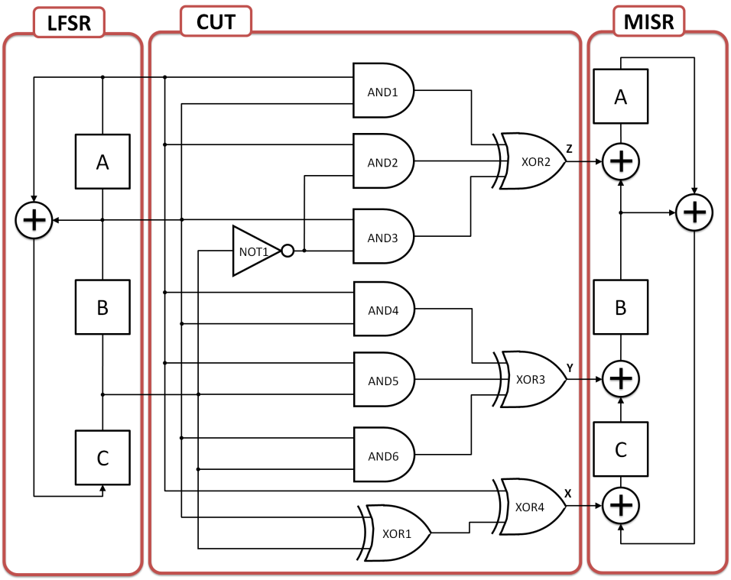
Figure 6. BIST scheme for exercise 1
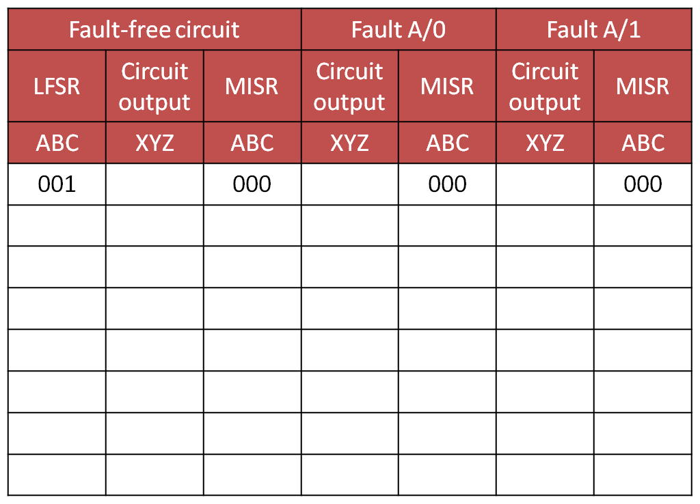
Table 2. Signature report for exercise 1

LAB 7: Test compression

We will use a non-scan RTL-level Verilog implementation of a simple 8-bit microcontroller. It is binary code compatible with the Microchip 16C57 microcontroller. This source code has been developed by Thomas Coonan and is publicly available at www.mindspring.com/~tcoonan (2011). According to the copyrights, it can be redistributed and/or modified in a source code form under the terms of the General Public License (GNU).

Exercise 1: Test pattern compression flow
Go to directory lab_7/ex_1. Notice that each step of the exercise has its own subdirectory, and common directories are used for netlists, libraries, and logfile reports.
- In the 0_lspec_synth directory synthesize the model of the given microcontroller [Procedure 7]. Hint: use the ami05_worst.syn library and attach source files in the following order: alu.v, dram.v, regs.v, idec.v, cpu.v.
- In directory 1 _scan invoke Tessent Scan on the gate-level netlist and insert 20 scan chains [Procedure 8].
- In directory 2_fs_pg run FastScan on the scan-inserted netlist (20 scan chains) and generate test patterns [Procedure 9]. Next, analyze the TestKompress report and answer these questions [Appendix 6].
- In the 3_tk_edt directory invoke TestKompress on the scan-inserted netlist (20 scan chains) and create TestKompress logic with 4 scan channels [Procedure 10]. Next, analyze the TestKompress report and answer the following questions [Appendix 6].
  - How many initial shifts are there?
  - What is the size of the decompressor?
  - What is compression per pattern?
- In the 4_lspec_synth_edtrm directory synthesize EDT logic using Leonardo Spectrum [Procedure 7]. Hint: use the ami05_worst.syn library and analyze source files in the following order: design_scan.v, design_edt.v, design_edt_top.v.
- In the 5_tk_pg directory run TestKompress on the synthesized top-level of the design and generate compressed test patterns [Procedure 9]. Next, analyze the TestKompress report and answer the following questions [Appendices 4 and 7].
    - What is the fault coverage and the test coverage?
    - How many test patterns are there?
    - What is the total data compression?

LAB 8: Fault diagnosis


Exercise 1: Logic level diagnosis
Go to directory lab_8/ex_1.
- Run ATPG for the circuit of Figure 7 using FastScan and save test patterns in ASCII format [Procedure 2].
- Analyze the fault report and determine fault equivalence classes [Procedure 4].
- Divide the test pattern set into isolated patterns.
- Analyze fault reports for particular test patterns and partition the faults into classes.
- Determine a diagnostic tree.
- Analyze the test responses for two case studies, complete Table 3 and determine failures.
- Improve the fault resolution by the generation of tests to distinguish faults: e₀ f₀ g₀.
- Enhance the diagnostic tree and explain why additional patterns can distinguish targeting fault sites.
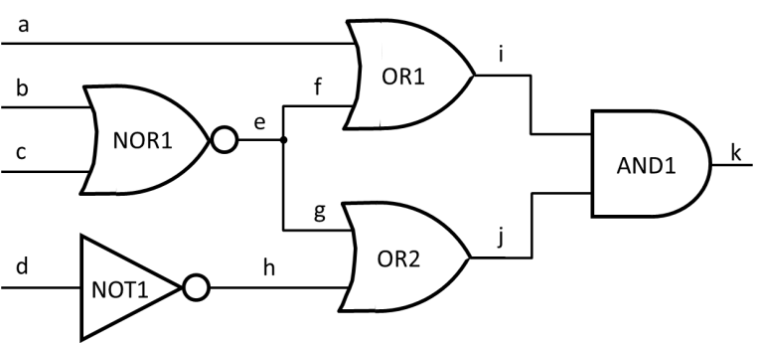
Figure 7. Circuit for exercise 1

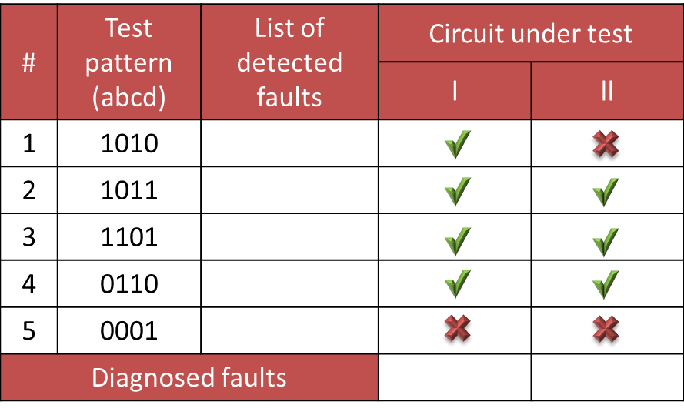
Table 3. Case study report for exercise 1

LAB 9: Iterative Diagnosis


Exercise 1: Iterative pattern generation
Go to directory lab_9/ex1.
- Run Tessent Diagnosis with the failure file (fail1.log) from one device [Procedure 11].
- Analyze the diagnosis report and determine the number of symptoms, the number of suspects and the diagnosis score [Appendix 8].
- Select a good candidate for the iterative diagnosis [Appendix 8].
- Invoke Tessent Diagnosis with an emulation of the selected failure and create new iterative test patterns [Procedure 11].
- Run Tessent Diagnosis for both created test pattern sets and failure files.
- Analyze the diagnosis report and compare results [Appendix 8]. How many suspects were reported for the symptom number 2 after the iterative diagnosis?

LAB 10: Memory Built-In Self-Test (BIST)

Exercise 1: Algorithm for programmable controller
Consider a memory built-in self-test scheme shown in Figure 8. Tessent MemoryBIST with programmable controller has been deployed to test a word-oriented memory array (128 x 8b). This architecture enables you to define customized test algorithms to target specific memory defects that are difficult to detect with the existing algorithms. The algorithm programing uses a specific syntax wrapper [Appendix 9]. For a complete description of the Algorithm wrapper syntax, refer to the Reference for Algorithm Wrapper Contents appendix.
Go to directory lab_10.
- Use the programmable controller to generate multiple data backgrounds to detect all coupling faults between neighboring cells of the same word.
- Use the following data backgrounds:
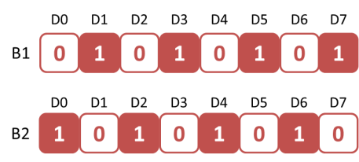
- Propose a sequence of data background instructions (write, read, compare). Use the wrapper and its contents to develop your algorithm (file 1.alg).
- Invoke ModelSim algorithm simulation (makealg file), which dumps simulation data around the area of the fault-injected memory and the memory BIST controller.
- Analyze the simulation report to examine the number of compare failures and verify a correctness of the proposed algorithm.

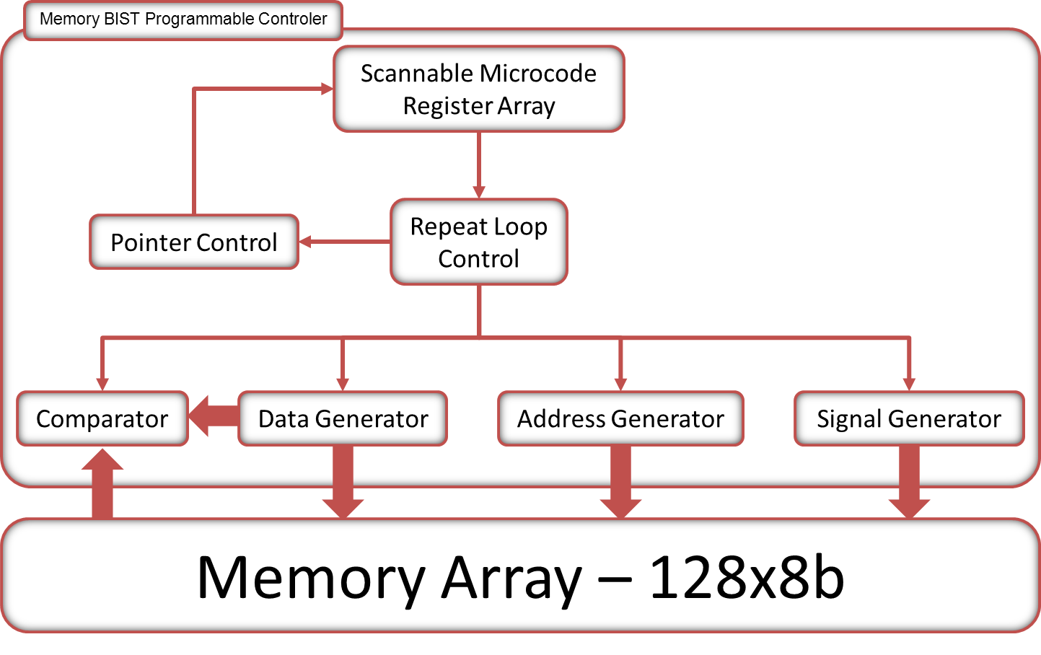
Figure 8. Memory BIST scheme for exercise 1


VLSI Testing
Procedures



Procedure 1: Running ATPG (simplified flow for combinational circuits)
- Tessent Shell needs the following files to be specified:
  - Gate-level netlist – contains Verilog gate-level design description.
  - ATPG library -- needed if the design contains modules not found in the netlist file.
  - Dofile – contains a series of commands to be executed in batch mode (this file is optional, all commands may be also invoked in an interactive mode).
  - Logfile – a logfile of messages (optional), add –replace to overwrite the previous logfile
- Run Tessent Shell using the following command:
$TESSENT_PATH/tessent –shell –dofile <dofile_name> /
-log <logfile_name> -replace
- Invoke test pattern generation and simulation context:
set_context patterns -scan
- Load design model:
read_verilog <circuit_filename.v>
- Load ATPG library file if needed for this design:
- read_cell_library <atpg.lib>Indicate the top module in the design:
set_current_design <top_module>
- Switch to analysis mode:
set_system_mode analysis
- Analyze Flattening, DRC and, Circuit Learning reports.
Notice that all available commands have a manual page that can be invoked as follows:
help <command_name>

To close Tessent Shell use command: exit -d
Procedure 2: Test pattern generation
After running Tessent Shell and analysis mode [Procedure 1],
- Indicate stuck-at fault model:
set_fault_type stuck
- Add a targeted list of faults or all faults:
add_faults -all
- Run Pattern Generation:
create_patterns
- Analyze the results [Procedure 4].

Procedure 3: Fault simulation with external test pattern set
After running Tessent Shell and analysis mode [Procedure 1], you can run Fault Simulation of a previously prepared external test patterns set.
- Indicate stuck-at fault model:
set_fault_type stuck
- Add all faults:
add_faults –all
- Indicate the path to external test patterns file (choose Ascii test patterns file format):
set_pattern_source external <patterns_filename.ascii> -ascii
- Run fault simulation:
simulate_patterns
- Analyze the results using command line or DFTVisualizer [Procedure 4].

Procedure 4: Fault coverage and detected fault analysis
A: using command line
In order to analyze results of ATPG or fault simulation use the following commands in the analysis mode.
- report_statistics
- report_faults –class <class_name>
- class names:
  - FULL – all fault classes
  - RE – redundant faults
  - DS – faults detected by simulation
  - EQ – equivalent faults

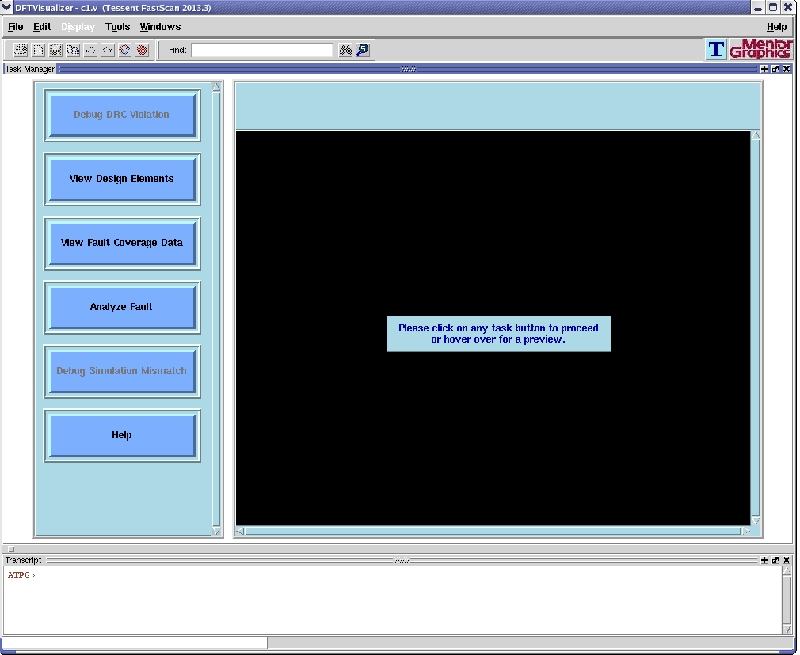
Figure 9: DFTVisualizer - View Fault Coverage Data window
B: using DFTVisualizer
- In order to analyze results of ATPG or fault simulation open a DFTVisualizer window using the command open_visualizer in the analysis mode.
- In the DFTVisualizer window select the View Fault Coverage Data option from the Task Manager and do the following (Figure 9).
- Setup the necessary test statistics reported in the Browser window by clicking appropriate buttons (Fault Coverage, Test Coverage, Fault By Category).
- From the main menu select Tools and click Analyze Faults…
- In the Faults & Statistics Options select the Entire Design.
- In the Report Faults Options select the Both of the Above.
- In the Fault Class indicate the targeted fault class (Figure 10)[Appendix 5].
- In the Reported Data click the Report Faults.
- Analyze the list of faults [Appendix 5].


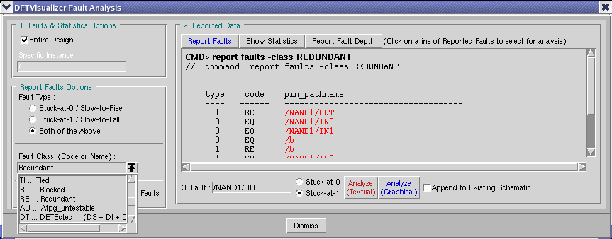
Figure 10: Fault Class Choices window
Procedure 5: HDL simulation
  - Run ModelSim: vsim &.
  - Create a design library and map to a physical library.
From File menu choose New, and next Library….
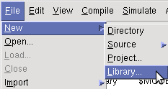

- In the Create a New Library window select a new library and a logical mapping to it.

- Type the name of your library in Library Name field, e.g. my_work_lib or leave empty and use the default library work.
- Click OK.
  - Compile HDL design files.
- From Compile menu choose Compile…
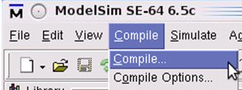

- In the Compile HDL Source File window select top-level file from a design directory and click Compile.
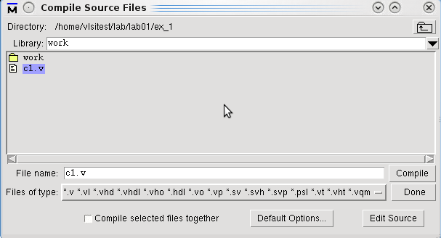

- Click Done to finish.
- Review the messages on the ModelSim Console window, check compiled modules and expand the working library in the Library pane.
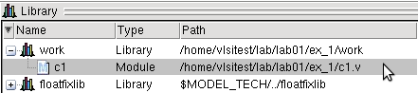

  - Simulate.
- From Simulate menu choose Start Simulation...
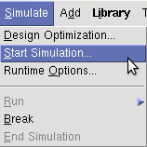

- In the Start Simulation window choose Design tab and from the available libraries select the top-level unit, disable optimization, and click OK.

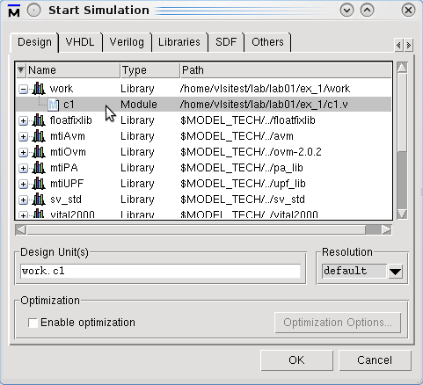

- Review messages printed to the ModelSim Console.
- Review signals of the design in the Objects window.
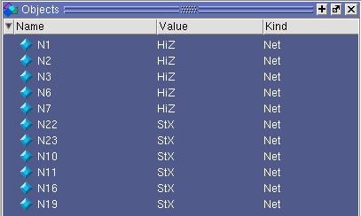
  - Open the waveform viewer and analyze the observable signals.
- Add all required signals in the top-level unit to the waveform viewer. In the Object window from the Edit menu choose Select All.
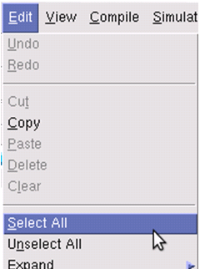


- Right-click on the highlighted signals and next select Add to Wave.
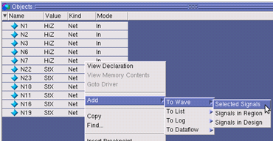

- To force the required state of input signals right-click on the appropriate signal and select Force… or Clock…. Depending on the selection you can set different properties of the excitation signal.
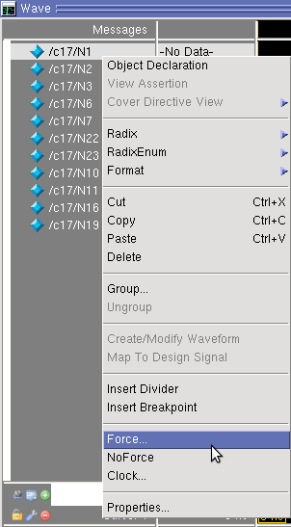 | 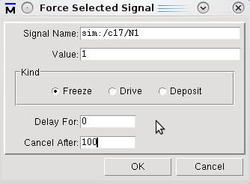
 | 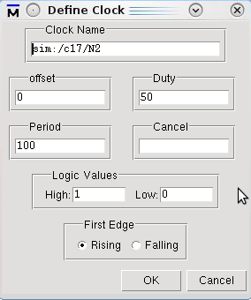

- To run simulation select Run and Run 100 from the Simulate menu.
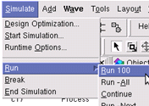

    - In the Wave window review simulated signals of the design.
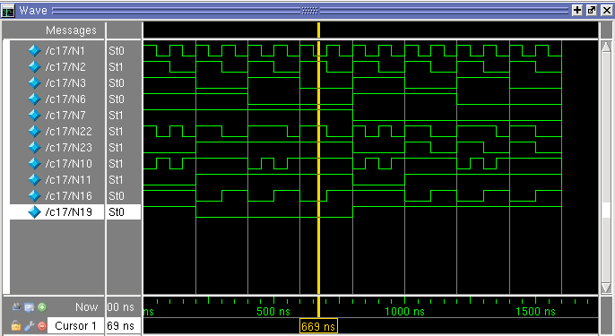

    - To restart simulation select Run and Restart from Simulate menu.


Procedure 7: Synthesizing HDL using Leonardo Spectrum
- Leonardo Spectrum needs three files to be specified as shown in Figure 11:
  - RTL model – synthesizable HDL description of your design.
  - Synthesis library – contains a description of testable models for logical gates.
  - Batch file – contains a series of commands to be executed by Leonardo Spectrum.
b. Leonardo Spectrum results:
- Technology specific netlist – a new netlist synthesized in accordance with a given technology.
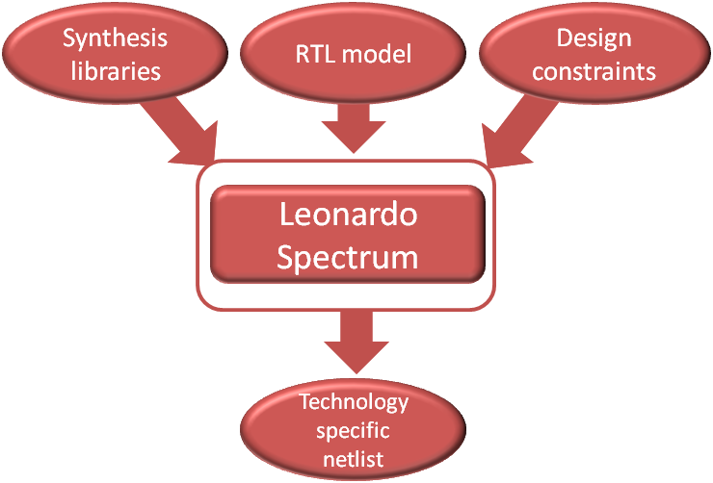
Figure 11: Leonardo Spectrum synthesis flow

c. First, you need to create a similar file and a directory structure as shown in the frame below:
<LAB_#>/ -- lab directory
spectrum_synth/ -- Leonardo Spectrum work directory
run_spectrum -- Leonardo Spectrum run script
spectrum.batch -- Leonardo Spectrum batch file
netlists/ -- HDL source files
libs/ -- libraries subdirectory
log/ -- reports subdirectory


d. Second, create the batch file <spectrum.batch> for Leonardo Spectrum:
//Load the library
load_library <tsmc035_typ>
//Read the HDL files
read { abmux.vhd alu.vhd control.vhd datamux.vhd top.vhd }
//Optimize the design to a technology
optimize
//Optionally set timing constraints
set_attribute -net clk -name clock_cycle -value 10
optimize_timing
//Generate reports
report_delay
report_area -cell
//Write out the netlist
set vhdl_write_use_packages {library ieee,adk; use ieee.std_logic_1164.all; use adk.adk_components.all;}
apply_rename_rules -ruleset VHDL
apply_rename_rules -ruleset VERILOG
auto_write ../netlist/design.v

e. Next, to run Leonardo Spectrum and synthesize RTL model, create the <run_spectrum> file according to the following call syntax:
$LEONARDO_SPECTRUM_PATH/spectrum \
-file <spectrum.batch> \
-logfile <logfile_name>

f. Finally, run pre-generated batch file: prompt > ./run_spectrum. Examine the logfile and verify if the netlist has been written.
Procedure 8: Scan chains insertion using Tessent Scan (batch mode)

This procedure introduces a scan chains insertion flow that you may use to create scan chains in your design at RTL level using Tessent Scan batch mode. Figure 12 illustrates the scan chains insertion flow.
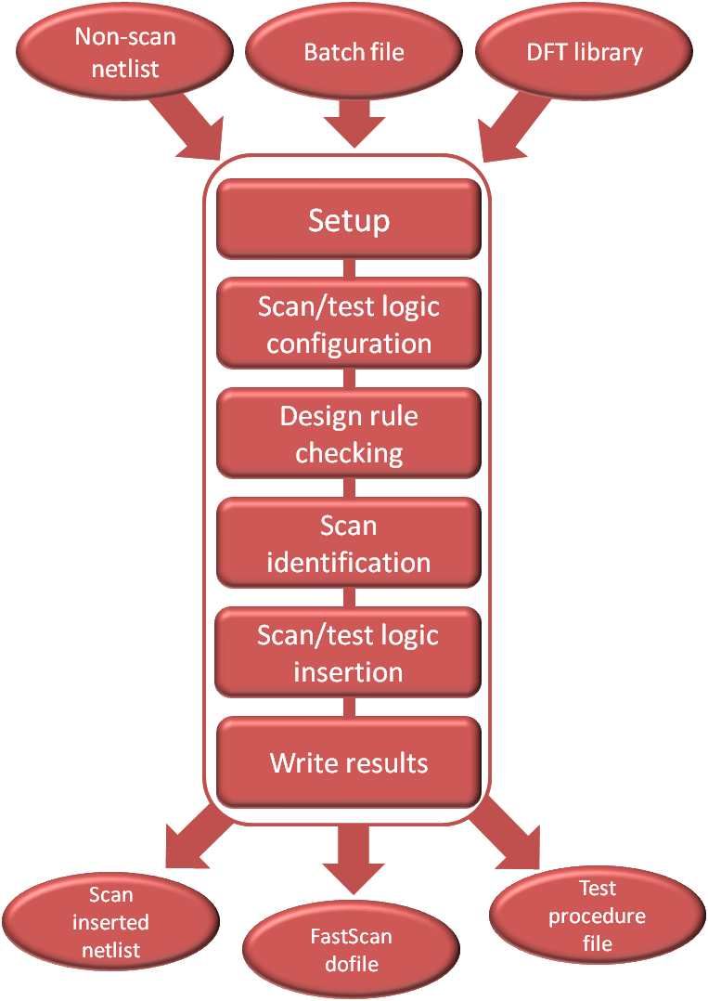
Figure 12: Tessent Scan scan chains insertion flow
- Tessent Scan needs three files to be specified.
  - Non-scan netlist – synthesizable HDL description of your design.
  - DFT library – contains a description of testable models for logic gates.
  - Dofile – contains a series of commands to be executed by Tessent Scan.
- Tessent Scan results.
  - Scan inserted netlist – a new netlist with inserted scan chains.
  - FastScan dofile – provides circuit setup and scan circuitry information used by FastScan for ATPG.
  - Test procedure file – contains cycle-based procedures and timing definitions used by FastScan to operate the scan structures within a design.
- First, you need to create a similar file and a directory structure as shown in the frame below:

<LAB_#>/ -- lab directory
scan_ins/ -- Tessent Scan work directory
run_scan -- scan insertion run script
scan.do -- scan insertion dofile
netlists/ -- HDL source files
libs/ -- libraries subdirectory
log/ -- reports subdirectory


- Second, create the dofile <scan.do> for Tessent Scan:
set_context dft –scan // Go to DFT mode
read_verilog <verilog_netlist>
analyze_control_signals –auto
// Setting parameters for the scan chains logic – 8 scans
insert_test_logic -number 8
// Save scan inserted netlist
write_design –output_file <verilog_netlist_with_scans> –verilog –replace
// Save test procedure and setup files with the filename prefix "design"
write_atpg_setup <scan_setup_filename>

- Next, to run Tessent Scan and generate a scan chains inserted design file create a <run_scan> file according to the following call syntax:
$TESSENT_PATH/tessent -shell \
-dofile <dofile_name> \
-logfile <logfile_name> -replace

- Finally, run pre-generated dofile: prompt > ./run_scan. Examine the transcript or logfile and verify that the netlist, dofile, and test procedure files have been written.


Procedure 9: Test pattern generation using Tessent Shell FastScan or TestKompress
This procedure introduces a test pattern generation flow shown in Figure 13 that you may use to create patterns for your design using Tessent FastScan or TestKompress.
When using TestKompress, test patterns are generated in a fashion similar to that of traditional ATPG (e.g., FastScan). In fact, TestKompress commands are compatible with most FastScan commands. During logic creation, a dofile containing setup information for the pattern generation phase is automatically generated (similarly to how Tessent Scan creates files describing the operation of the inserted scan chain circuitry).
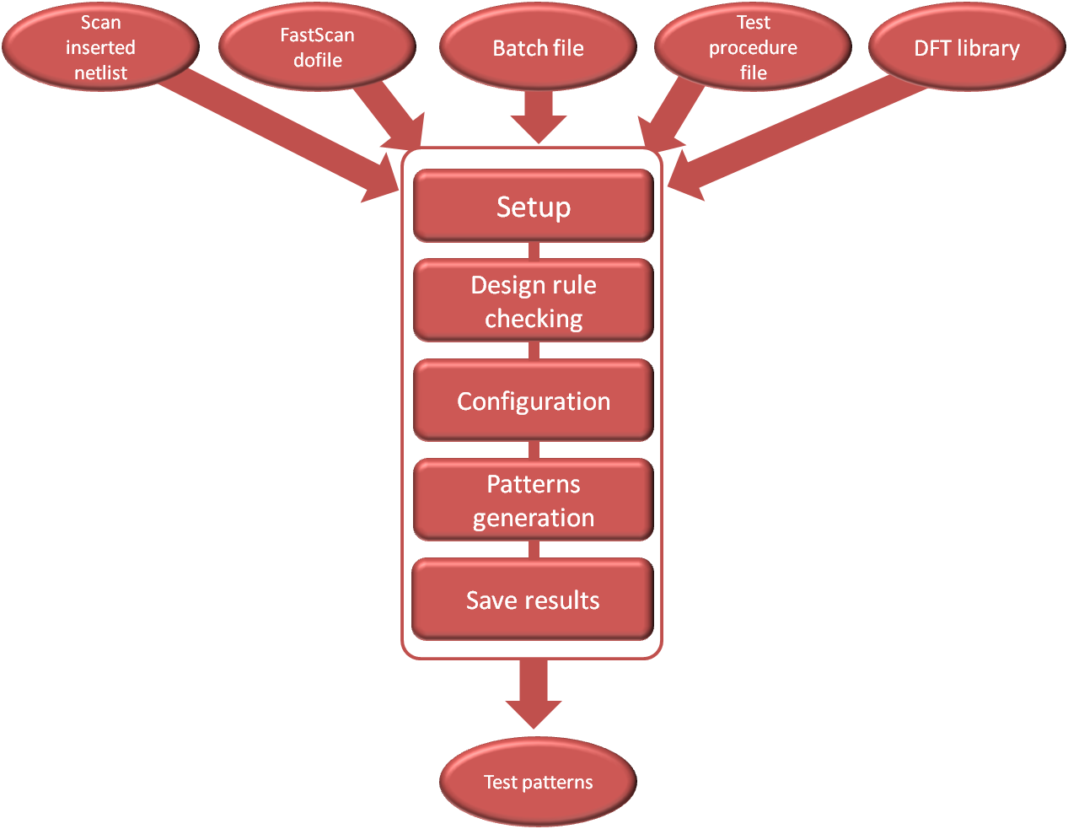
Figure 13: FastScan (TestKompress) test patterns generation flow
- FastScan (TestKompress) needs five files to be specified:
  - Scan inserted netlist – a netlist with inserted scan chains.
  - FastScan setup (created by Tessent Scan) – it provides circuit setup and scan circuitry information.
  - Test procedure file – contains cycle-based procedures and timing definitions, used by FastScan to operate the scan structures within a design.
  - Dofile – contains a series of commands to be executed by FastScan.
  - DFT library – contains a description of testable models for logic gates.
- FastScan (TestKompress) results:
  - Test patterns – test patterns description file [Appendices 1 and 2].

- First, you need to create the same file and directory structure as shown in the frame below:
<LAB_#>/ -- lab directory
fs_pat_gen/ -- FastScan work directory
run_fs -- FastScan run script
fs.dofile -- FastScan dofile
netlists/ -- HDL source files
libs/ -- libraries subdirectory
patt/ -- test patterns subdirectory
log/ -- reports subdirectory

- Second, create the dofile <fs.do> for FastScan (TestKompress):
set_context patterns –scan
read_verilog <verilog_netlist_with_scans>read_cell_library <atpg.library>
set_current_design <top_design_name>
// Read scan setup
dofile <scan_setup_filename>
// Go to atpg mode
set_system_mode analysis
// Pattern generation, default is stuck-at
create_patterns
report_statistics
write_patterns ../patt/par.v –verilog –parallel –replace
write_patterns ../patt/ser.v –verilog –serial -replace
exit

- Next, to run FastScan (TestKompress) and generate test patterns create a run_fs (run_tk) file according to the following call syntax:
$TESSENT_PATH/tessent -shell \
-dofile <dofile_name> \
-logfile <logfile_name> -replace

Procedure 10: EDT logic insertion using TestKompress

This procedure presents EDT logic insertion flow that you may use to implant test compression logic into your design and obtain initial test coverage and compression estimates by using TestKompress.
- TestKompress needs five files to be specified:
  - Scan inserted netlist – a netlist with inserted scan chains.
  - TestKompress dofile – (created by Tessent Scan) provides circuit setup and scan circuitry information.
  - Test procedure file – (created by Tessent Scan) contains cycle-based procedures and timing definitions, used by TestKompress to operate the scan structures within the design.
  - Dofile – contains a series of commands to be executed by TestKompress.
  - DFT library – contains a description of testable models for logic gates.
- TestKompress results:
  - Design_edt.v – TestKompress circuitry (Verilog RTL).
  - Design_edt_top.v – top level wrapper (instantiates core and TestKompress logic).
  - Design_core_blackbox.v – blackbox description of the core (used for synthesis).
  - Design_dc_script.scr – Design Compiler synthesis script.
  - Design_edt.dofile – dofile for TestKompress (test pattern generation).
  - Design_edt.testproc – test procedure file (test pattern generation).
  - Design_bypass.dofile – dofile for bypass mode.
  - Design_bypass.testproc detected – procedure file for bypass mode.
- First, you need to create the same file and a directory structure as shown in the frame below:

<LAB_#>/ -- lab directory
tk_ip/ -- TestKompress work directory
run_tk_ip -- run script
tk_ip.do -- TestKompress dofile
netlists/ -- HDL source files
libs/ -- libraries subdirectory
patt/ -- test patterns subdirectory
log/ -- reports subdirector

- Second, create the dofile <tk_ip.do> for TestKompress:
set_context dft -edt
read_verilog <verilog_netlist_with_scans>
set_current_design <top_design_name>
read_cell_library <atpg.library>
//Use dofile from Tessent Scan run
dofile design.dofile
//Settings for EDT
set_edt_options -input_channels 4 -output_channels 4
//Run DRCs and go to ATPG mode
set_system_mode analysis
//Create Patterns as a sanity check to make sure
//that you are getting the same coverage as FastScan
create_patterns
//Save the EDT logic and synthesis scripts
//with the filename prefix "design".
write_edt_files ./design -verilog -replace
//Exit TestKompress
exit -d

- Next, to run TestKompress and insert test logic create a <run_tk_ip> file according to the following call syntax:
$TESSENT_PATH/tessent -shell \
-dofile <dofile_name> \
-logfile <logfile_name> -replace

Procedure 11: Diagnosis using Tessent Diagnosis

This procedure presents how to invoke Tessent Diagnosis on a failure report generated on automatic test equipment (ATE). These failures can be analyzed by Tessent Diagnosis and report the suspected defect locations and failure modes.
- Tessent Diagnosis needs five files to be specified:
  - Flat model netlist – a netlist with test procedure information for pattern generation.
  - Dofile – contains a series of commands to be executed by Tessent Diagnosis.
  - Test patterns – test patterns description file used in testing process.
  - Failure file – a report file as derived from the ATE.
- Tessent Diagnosis results:
  - Diagnosis report – a file with various diagnosis statistics (defect location, type, score).
- First, you need to create the same file and a directory structure as shown in the frame below:

<LAB_#>/ -- lab directory
diagnosis/ -- Tessent Diagnosis work directory
run_diag -- run script
ya.do -- Tessent Diagnosis dofile
netlists/ -- flat model netlist
patt/ -- test patterns subdirectory
fail/ -- failure files subdirectory
log/ -- reports subdirectory

- Second, create the dofile <diag.do> for Tessent Diagnosis:
set_context patterns –scan_diagnosis
read_flat_model ../netlists/design.flat
// read external pattern file
set_pattern_source external ./patt/pat_core.ascii –ascii
// read failure file
read_failure ./fail1.log
// run diagnosis and save report
diagnose_failure -output fail1.rep -repl


- Next, to use Tessent Diagnosis and run diagnosis create a <run_diag> file according to the following call syntax:

$MGC_HOME/bin/tessent \
-dofile diag.do \
-log ../log/diag.log –rep

- Additional commands:
  - write_failures – emulates the defect and produces a new failure file,
  - create_diagnosis_patterns -diagnosis_report <diagnosis report file> – creates additional internal test patterns to improve a diagnostic resolution.




VLSI Testing
Appendices


Appendix 1: Test pattern description file for combinational designs
FastScan handles several application-dependent storage formats for test patterns. One of them (ASCII test pattern file for f/1 from Lab 1, Ex 1) is presented below.
ASCII_PATTERN_FILE_VERSION = 2;
SETUP =
declare input bus "PI" = "/a", "/b", "/c", "/d", "/e";
declare output bus "PO" = "/z";
end;

SCAN_TEST =
pattern = 0;
force "PI" "11011" 0;
measure "PO" "1" 1;
end;

Appendix 2: Test pattern description file for sequential designs
FastScan handles several application-dependent storage formats for test patterns. One of them (ASCII) is presented below.
SETUP =
TESCYCLE_WIDTH = 3;
DECLARE INPUT BUS "ibus" = "/H", "/INP(0)", "/INP(1)", "/INP(2)",
"/INP(3)";
DECLARE OUTPUT BUS "obus_3" = "/OUTP(0)";
CLOCK "/H" =
OFF_STATE = 0;
END;
END;
CYCLE_TEST =
CYCLE = 0;
FORCE "ibus" "01111" 0;
FORCE "ibus" "11111" 1;
FORCE "ibus" "01111" 2;
MEASURE "obus_3" "1" 3;
CYCLE = 1;
FORCE "ibus" "01100" 0;
FORCE "ibus" "11100" 1;
FORCE "ibus" "01100" 2;
MEASURE "obus_3" "1" 3;
END;


Appendix 3: Primitive polynomials of degree up to 50

 | 5 coefficients | 7 coefficients | 9 coefficients
9 | 97420 | 9753210 | 986543210
10 | 106520 | 10864210 | 1097643210
11 | 118520 | 11975310 | 1197643210
12 | 127430 | 12 1096420 | 12 108764210
13 | 139730 | 13 1086420 | 13 119764210
14 | 149720 | 14 11 107520 | 14 12 10975310
15 | 15 11630 | 15 1297420 | 15 13 11975320
16 | 16 10740 | 16 13 12 9 6 3 0 | 16 15 13 1086420
17 | 17 12840 | 17 14 118530 | 17 14 12 1086420
18 | 18 15940 | 18 14 129630 | 18 16 13 1196420
19 | 19 13940 | 19 16 139630 | 19 16 13 1086420
20 | 20 13950 | 20 17 13 10630 | 20 17 15 1297420
21 | 21 17 11 5 0 | 21 17 13 10630 | 21 18 15 12 107520
22 | 22 16 12 5 0 | 22 17 12 10630 | 22 19 17 14 118520
23 | 23 17 11 5 0 | 23 19 15 11730 | 23 19 15 12 106420
24 | 24 20 11 5 0 | 24 19 16 13850 | 24 20 17 15 129630
25 | 25 18 12 6 0 | 25 22 17 13840 | 25 22 18 15 129630
26 | 26 17 13 6 0 | 26 21 17 13940 | 26 23 20 16 139630
27 | 27 20 13 7 0 | 27 24 19 14 10 5 0 | 27 23 20 16 129630
28 | 28 21 15 7 0 | 28 25 20 15 10 5 0 | 28 26 22 18 14 10630
29 | 29 20 14 8 0 | 29 24 19 14 1050 | 29 25 21 17 14 10630
30 | 30 20 13 8 0 | 30 24 19 14950 | 30 27 22 18 139630
31 | 31 23 15 7 0 | 31 25 20 15 10 5 0 | 31 27 23 19 15 11730
32 | 32 25 15 7 0 | 32 27 21 16 10 5 0 | 32 28 23 20 17 12840
33 | 33 25 16 8 0 | 33 29 23 17 11 5 0 | 33 29 24 20 16 12840
34 | 34 24 15 7 0 | 34 27 20 16 10 5 0 | 34 30 26 21 16 12840
35 | 35 27 17 8 0 | 35 28 23 17 10 5 0 | 35 31 26 22 17 12840
36 | 36 25 17 8 0 | 36 29 24 18 12 6 0 | 36 31 27 22 17 13840
37 | 37 28 18 9 0 | 37 31 25 18 12 6 0 | 37 32 27 23 18 13950
38 | 38 28 20 9 0 | 38 33 26 20 12 6 0 | 38 33 28 23 18 14940
39 | 39 28 18 9 0 | 39 32 26 19 13 7 0 | 39 34 29 24 19 14950
40 | 40 29 21 10 0 | 40 34 27 19 12 6 0 | 40 36 30 26 20 15 1050
41 | 41 29 19 10 0 | 41 34 27 20 13 6 0 | 41 36 31 26 20 15 10 5 0
42 | 42 31 19 10 0 | 42 34 28 20 14 7 0 | 42 36 31 26 21 16 11 5 0
43 | 43 33 21 10 0 | 43 36 28 20 14 7 0 | 43 37 31 25 20 15 10 5 0
44 | 44 31 22 11 0 | 44 37 29 21 14 7 0 | 44 38 32 27 23 17 11 5 0
45 | 45 32 22 10 0 | 45 37 31 23 16 8 0 | 45 39 33 27 22 16 11 5 0
46 | 46 33 23 10 0 | 46 39 30 21 14 7 0 | 46 40 34 28 23 17 11 5 0
47 | 47 35 24 11 0 | 47 38 29 21 14 7 0 | 47 41 35 29 23 17 11 5 0
48 | 48 38 26 13 0 | 48 41 34 25 16 7 0 | 48 43 36 30 25 19 12 6 0
49 | 49 35 23 12 0 | 49 40 31 24 16 8 0 | 49 43 37 31 24 18 12 6 0
50 | 50 39 24 12 0 | 50 43 34 24 16 8 0 | 50 44 37 30 25 18 12 6 0


Appendix 4: Test coverage report
Use the report statistic command to generate coverage statistics.
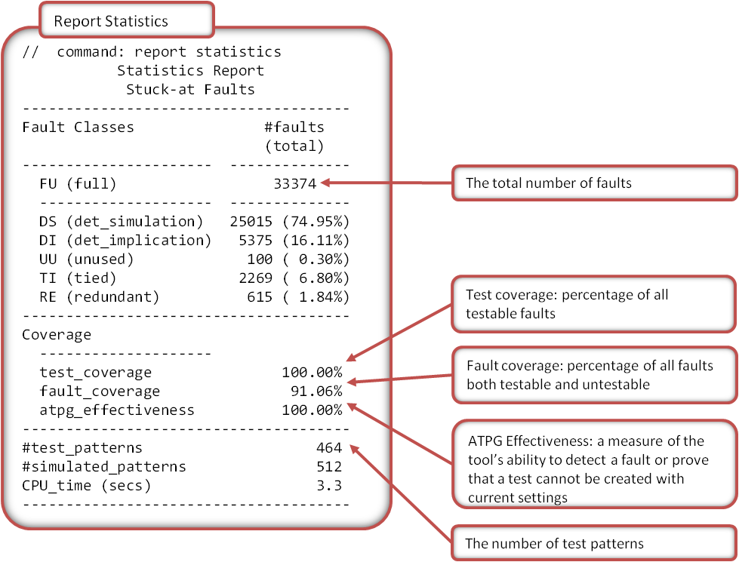
Appendix 5: Faults report
Use the REPort faults command in the FastScan or TestKompress dofile to generate the list of the detected faults.
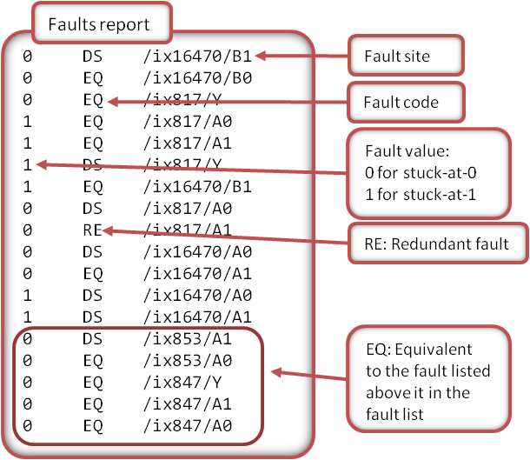

Appendix 6: EDT configuration report

Use the REPort EDT Configuration command in the FastScan or TestKompress dofile to generate the basic EDT configuration report.
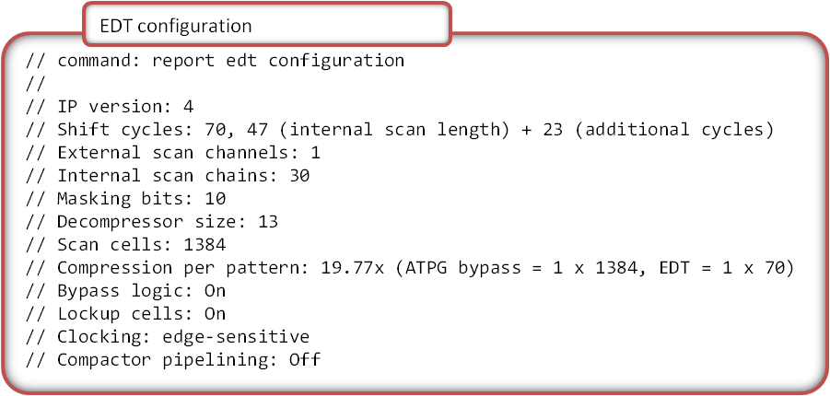
Appendix 7: Compression ratio
Use the REPort Scan Volume command to generate compressed and uncompressed data volume statistics.
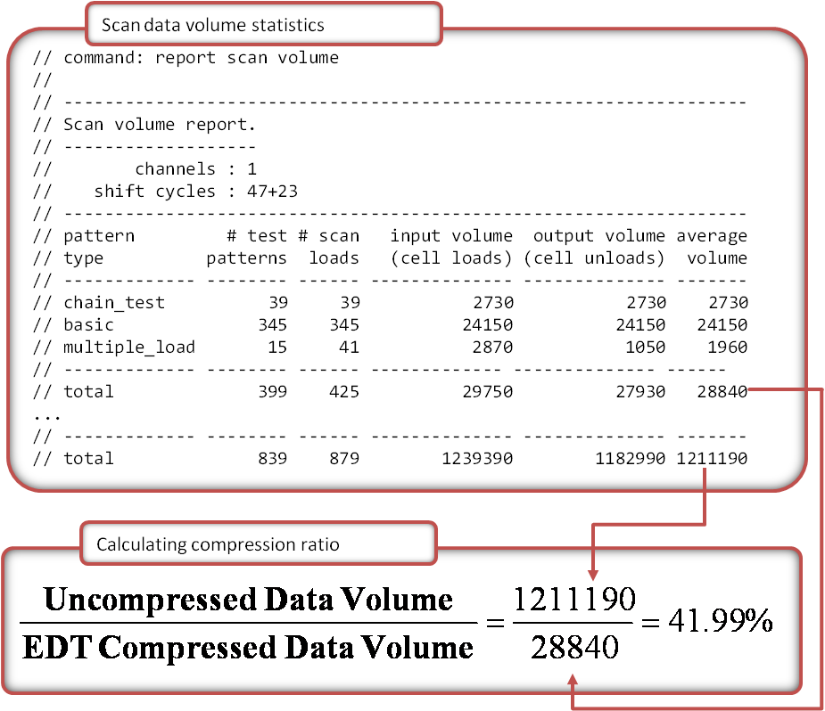


Appendix 8: Diagnosis report

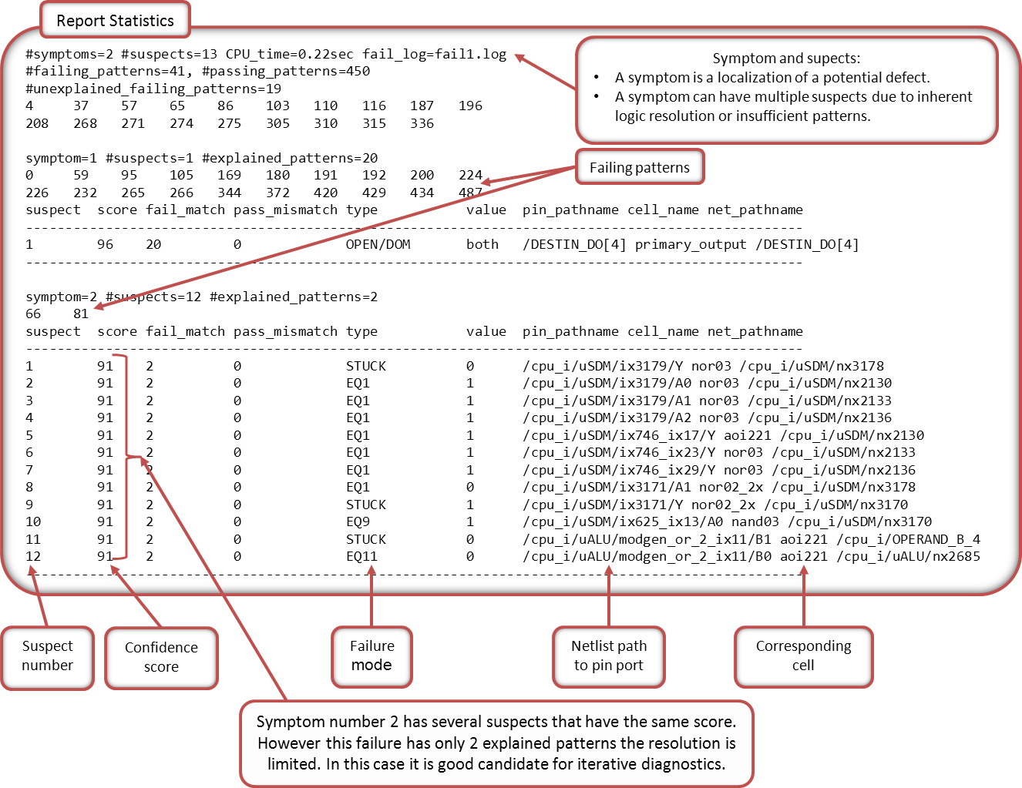

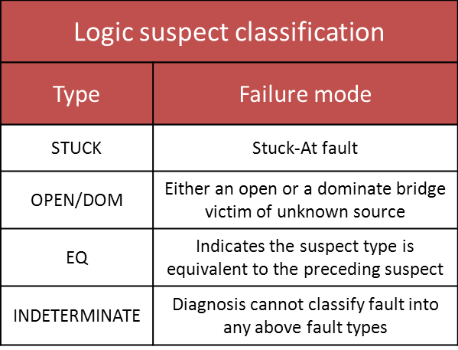


Appendix 9: Tessent MemoryBIST algorithm syntax
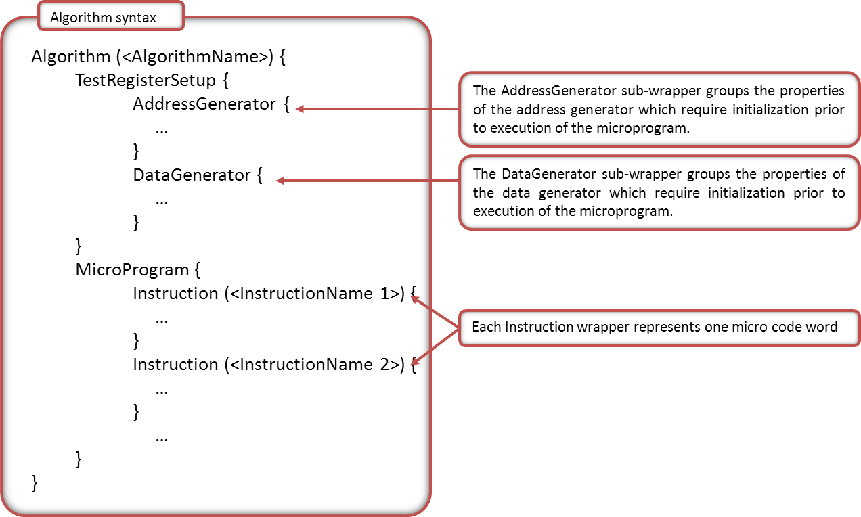

J. Rajski, J. Tyszer, “Primitive Polynomials Over GF(2) of Degree up to 660 with Uniformly Distributed Coefficients,” JETTA, vol. 19, 2003.

